3CD MATHEMATICS SPECIALIST – INVESTIGATION 1 MARKING KEY

1. For n an integer, the product 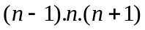 is the product of three consecutive ü
integers. In any 3 consecutive integers there will be at least one multiple of 2 and ü
a multiple of 3. Any product which is a multiple of both 2 and 3 is a multiple of 6, ü
and is therefore divisible by 6.

2. Prove: 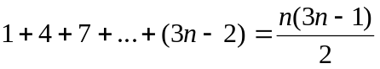 for all positive integers n.
Step 1: Verify the statement is true when n = 1.

L.H.S. = 1
R.H.S. = 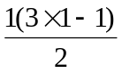
= 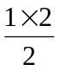
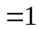 ü
- Statement is true for n = 1.

Step 2: Assume the statement is true for n = k.
That is, 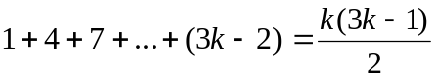 ü
Step 3: Prove the statement is true for n = k + 1
That is, prove 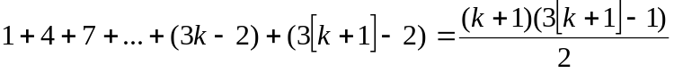
=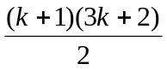 ü
L.H.S.=
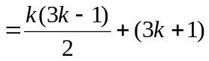 (from step 2) ü
=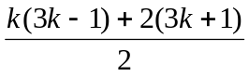 ü
=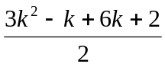
=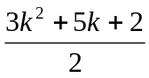 ü
=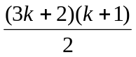 ü

= R.H.S.

⇒ The statement is true for n = k + 1 if it is true for n = k.

Step 4: As the statement is true for n = 1, it must be true for n = 2.
As the statement is true for n = 2, it must be true for n = 3 and so on.
Hence, 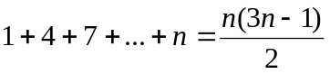 is true for all positive integers n. ü

3. Prove 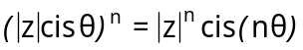 for all positive integers n.

Step 1 Verify the statement is true for n = 1
LHS = 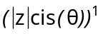
= 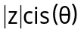
RHS = 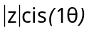
= 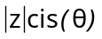
Statement true for n=1 ü

Step 2 Assume it is true for n = k
That is, 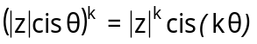 ü

Step 3 Prove the statement is true for n = k + 1

That is, prove 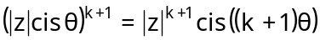 ü

LHS = 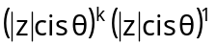

= 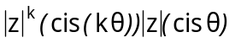 Step 1 and 2 ü
= 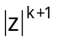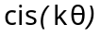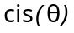
= ü
= ü
= ü
= 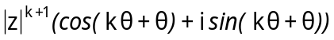 ü
= 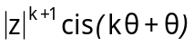
= 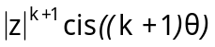
= RHS

Step 4: As the statement is true for n = 1, it must be true for n = 2.
As the statement is true for n = 2, it must be true for n = 3 and so on.
Hence, is true for all positive integers n. ü

